Problem
Traditional multi-threaded application cannot handle multiple submission requests at a time.

Classes
- Student Class: submitExam() - simulate the submission
- SubmissionStats - Output the submission stats (95% success rate)
- NewSubmissionSystem - numberOfStudents --> no of requests coming in
- Suggested Thread Pool - newFixedThreadPool();
newCachedThreadPool can grow and shrink as needed. Possibility of system crash. That’s why we use newFixedThreadPool.
- ExamSubmissionSimulator (main) - create students
Student class - submitExam()
- Thread.sleep(random.nextInt(10) + 1); // submission process simulation
- if(random.nextInt(100) < 5){
return false; // 5% submission failure rate.
}
return true; // 95% submission success rate.
Task 01
- Refer to AtomicInteger class implementation.
- To avoid overhead. (This will solve the performance issue)
- volatile & synchronized have higher overhead.
- AtomicInteger supports Compare-And-Swap (CAS)
- incrementAndGet - ++i
- getAndIncrement - i++
Task 02
- Refer to the usage of the CountDownLatch. - processSubmissions()
- ContDownLatch countdown = new CountDownLatch(20);
//count (parameter) = no of tasks

Royal Manchester Hospital A&E Patient Management System

Scenario Analysis
This is a classic producer-consumer concurrent programming problem with additional complexity:
- Producers: Patient arrivals (random, continuous)
- Consumers: Multiple consultants (3 per shift, working concurrently)
- Constraints: Specialty matching, shift rotations, thread safety

System Architecture & Classes Required

Core Classes:
Class | Purpose
Patient | Data model representing a patient with specialty needs
Speciality | Enum defining consultant specialities
Consultant | Runnable consumer that processes patients
PatientQueue | Thread-safe queue with specialty-based retrieval
PatientArrivalSimulator | Producer generating random patient arrivals
ShiftManager | Controls day/night shift rotations
HospitalSimulation | Main orchestrator class

Concurrency Components:
- BlockingQueue for thread-safe patient queue
- ReentrantLock for fine-grained locking
- ExecutorService for managing consultant threads
- ScheduledExecutorService for shift management
- AtomicInteger for statistics tracking

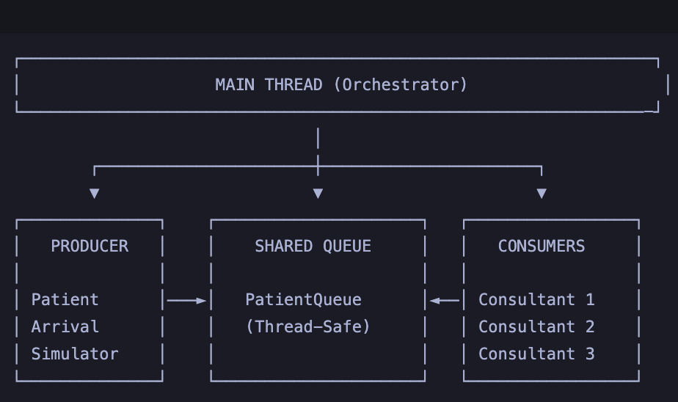
<truncated 389 lines> ✅ Dr. Emma Thompson [Surgery] COMPLETED treating Patient ID: 1039 | Duration: 2s ⏳ Consultant (Surgery) waiting for patients... ⏳ Consultant (Cardiology) waiting for patients... 📥 NEW ARRIVAL: Patient[ID=1040, Name=Isla Robinson, Needs=Cardiology, Arrived=19:45:55] | Queue Size: 0 🏥 Dr. David Lee [Cardiology] TREATING: Patient[ID=1040, Name=Isla Robinson, Needs=Cardiology, Arrived=19:45:55] | Waited: 0s ✅ Dr. David Lee [Cardiology] COMPLETED treating Patient ID: 1040 | Duration: 2s ⏳ Consultant (Cardiology) waiting for patients... 📥 NEW ARRIVAL: Patient[ID=1041, Name=Sophia White, Needs=Surgery, Arrived=19:45:59] | Queue Size: 0 🏥 Dr. Emma Thompson [Surgery] TREATING: Patient[ID=1041, Name=Sophia White, Needs=Surgery, Arrived=19:45:59] | Waited: 0s 📥 NEW ARRIVAL: Patient[ID=1042, Name=Olivia Williams, Needs=Surgery, Arrived=19:46:00] | Queue Size: 1 📥 NEW ARRIVAL: Patient[ID=1043, Name=Isabella Johnson, Needs=Paediatrics, Arrived=19:46:02] | Queue Size: 1 🏥 Dr. James Wilson [Paediatrics] TREATING: Patient[ID=1043, Name=Isabella Johnson, Needs=Paediatrics, Arrived=19:46:02] | Waited: 0s ✅ Dr. Emma Thompson [Surgery] COMPLETED treating Patient ID: 1041 | Duration: 2s 🏥 Dr. Emma Thompson [Surgery] TREATING: Patient[ID=1042, Name=Olivia Williams, Needs=Surgery, Arrived=19:46:00] | Waited: 1s ⏳ Consultant (Cardiology) waiting for patients... 📥 NEW ARRIVAL: Patient[ID=1044, Name=George Wilson, Needs=Cardiology, Arrived=19:46:04] | Queue Size: 0 🏥 Dr. David Lee [Cardiology] TREATING: Patient[ID=1044, Name=George Wilson, Needs=Cardiology, Arrived=19:46:04] | Waited: 0s ✅ Dr. James Wilson [Paediatrics] COMPLETED treating Patient ID: 1043 | Duration: 2s ⏳ Consultant (Paediatrics) waiting for patients... 🔄 ═══════════════════════════════════════════════════ 🔄 PERFORMING SHIFT CHANGE 🔄 Time: 19:46:05 🔄 ═══════════════════════════════════════════════════ ☀️ ═══════════════════════════════════════════════════ ☀️ DAY SHIFT STARTING ☀️ ═══════════════════════════════════════════════════ 👨‍⚕️ Dr. Sarah Chen [Paediatrics] - STARTED SHIFT at 19:46:05 👨‍⚕️ Dr. Michael O'Brien [Surgery] - STARTED SHIFT at 19:46:05 ⏳ Consultant (Paediatrics) waiting for patients... ⏳ Consultant (Surgery) waiting for patients... 👨‍⚕️ Dr. Aisha Patel [Cardiology] - STARTED SHIFT at 19:46:05 ⏳ Consultant (Cardiology) waiting for patients... ════════════════════════════════════════════════════════════ INITIATING GRACEFUL SHUTDOWN ════════════════════════════════════════════════════════════ ✅ Dr. Emma Thompson [Surgery] COMPLETED treating Patient ID: 1042 | Duration: 4s 👨‍⚕️ Dr. Emma Thompson [Surgery] - ENDED SHIFT at 19:46:07 | Patients Treated: 8 🚑 Patient Arrival Simulator STOPPED ⏳ Allowing remaining patients to be processed... ✅ Dr. David Lee [Cardiology] COMPLETED treating Patient ID: 1044 | Duration: 4s 👨‍⚕️ Dr. David Lee [Cardiology] - ENDED SHIFT at 19:46:08 | Patients Treated: 7 🛑 Stopping Shift Management System... 👨‍⚕️ Dr. Sarah Chen [Paediatrics] - ENDED SHIFT at 19:46:12 | Patients Treated: 8 👨‍⚕️ Dr. James Wilson [Paediatrics] - ENDED SHIFT at 19:46:12 | Patients Treated: 5 👨‍⚕️ Dr. Michael O'Brien [Surgery] - ENDED SHIFT at 19:46:12 | Patients Treated: 9 👨‍⚕️ Dr. Aisha Patel [Cardiology] - ENDED SHIFT at 19:46:12 | Patients Treated: 8 👨‍⚕️ Dr. David Lee [Cardiology] - ENDED SHIFT at 19:46:12 | Patients Treated: 7 ✅ Shift change completed successfully ╔═══════════════════════════════════════════════════╗ ║ PATIENT QUEUE STATISTICS ║ ╠═══════════════════════════════════════════════════╣ ║ Total Patients Added: 45 ║ ║ Total Patients Treated: 45 ║ ║ Currently Waiting: 0 ║ ╠═══════════════════════════════════════════════════╣ ║ Paediatrics Queue: 0 ║ ║ Surgery Queue: 0 ║ ║ Cardiology Queue: 0 ║ ╚═══════════════════════════════════════════════════╝ 🛑 Shift Management System stopped ✅ Shutdown complete ╔═══════════════════════════════════════════════════════════════════════╗ ║ FINAL SIMULATION REPORT ║ ╠═══════════════════════════════════════════════════════════════════════╣ ║ ║ ║ 📊 Total Patients Arrived: 45 ║ ║ ✅ Total Patients Treated: 45 ║ ║ ⏳ Patients Still Waiting: 0 ║ ║ ║ ╠═══════════════════════════════════════════════════════════════════════╣ ║ INDIVIDUAL CONSULTANT PERFORMANCE ║ ╠═══════════════════════════════════════════════════════════════════════╣ ║ ☀️ DAY SHIFT ║ ║ Dr. Sarah Chen [Paediatrics] Treated: 8 ║ ║ Dr. Michael O'Brien [Surgery] Treated: 9 ║ ║ Dr. Aisha Patel [Cardiology] Treated: 8 ║ ║ 🌙 NIGHT SHIFT ║ ║ Dr. James Wilson [Paediatrics] Treated: 5 ║ ║ Dr. Emma Thompson [Surgery] Treated: 8 ║ ║ Dr. David Lee [Cardiology] Treated: 7 ║ ║ ║ ╠═══════════════════════════════════════════════════════════════════════╣ ║ 🎯 Processing Efficiency: 100.0% ║ ║ ║ ╚═══════════════════════════════════════════════════════════════════════╝ 📅 End Time: 2026-01-01 19:46:12

